**COURSEWORK COVER SHEET/RECEIPT**

Each element of coursework submitted for assessment must be accompanied by a completed copy of this sheet. Coursework submitted for assessment without a completed coversheet **will not be marked.** Coursework will not be returned. It is the learner’s responsibility to keep a copy of all assessment material they submit.

|  |
| --- |
| *Must be completed by the learner*    **Learner Name: Arturs Pilugins**    **Course: Games Design Level:5 Tutor: Ray Quinn**    **Module Web Authoring Assignment Title: Skills No 1**    **Date Out: 12/10/22 Date Due: 16/11/22 Date Submitted:** _________ |
| *Must be completed by the tutor*  Provisional Mark /Grade: *Extension Granted* Yes  **□** No □    *Comment:* |

**Assignment No 1 – 30% Weighting**

# Web Authoring L5

5N1910

**Computer Games Level 5**

**2022/2023**

Date Out: 12/10/2022 Date Due: 16/11/2022

|  |  |  |  |
| --- | --- | --- | --- |
| **Student Work Submitted** | **Student Work Marked** | **IV Check** | **Extern Check** |
|  |  |  |  |

**Marks will be awarded as per QQI module descriptor.**

|  |  |  |
| --- | --- | --- |
| **Assessment Criteria** | **Maximum** **Mark** | **Learner Mark** |
| ● Assign No 1 - HTML & CSS **(30 Marks)**    ○ Presentation of Website Material  ○ Design Storyboard  ○ Colour Scheme Used  ○ Structure Diagram  ○ Folder Structure  ○ HTML Codes (Accurate)  ○ CSS Code (Accurate)  ○ Code Documented correctly  ○ Actual Web Pages Screen Layout  ○ Suitable Navigation System devised  ○ Files Uploaded correctly | **5**  **3**  **3**  **3**  **1**  **5**  **5**  **2**  **2**  **1** | **5**  **3**  **3**  **3**  **1**  **5**  **5**  **2**  **2**  **1** |
| **Total Mark** | **30** | **30** |

**Name:**

**Date:**

**Class:** Games Design Software L5

**Module**: Web Authoring

***By signing the below line you are stating that, the work handed in, is of your own work and has not been copied and / or parts of which have been taken from another source. This includes the work given out by the tutor/teacher this year***.

## Submission Information

**Important**

* **Use the cover sheet provided to add your date, name, class and full subject name.**

* **The presented document is your final submission and cannot be returned for redrafting; therefore ensure all the checks have been done prior to submitting.**

* **Due date is final - 16/11/2022 between 2:00pm and 04:00 pm only.**

* **Plagiarism of any kind or size will be subject to MI quality assurance procedures as stated in your student handbook handed out at the start of the year.**

* **Late submissions will not be accepted in this case without prior approval.**

* **Submissions must be uploaded to Moodle on time. College assignment receipt signed for and dated handed up.**

* **Tick the Box on Moodle stating this is your own work and submit.**

## **Guidelines**

In this assignment you are asked to produce a web site on the creation and development of the Internet and the World Wide Web in recent years. Your site should include pages that examine a range of different aspects of concerning both the Internet and WWW that are of interest to you. It is to be no more than 10 pages in length and include a contact/ feedback page.

Your pages are required to use a wide range of HTML tags and make use of both Inline and Internal CSS code. External Style sheets are not part of this assignment. They should be easy to navigate and adopt a clear design structure. All Images inserted into your website are to use relative linking instead of absolute linking.

**Your Home Page should display the following information**

Module Name: Web Authoring

Your Name

Web Assignment No 1 Your Class

**Hand Up:**

* Completed document to be uploaded to Moodle on time in this document.
* Website files to be shared on OneDrive and all links and images must work from the teachers PC. It is the learner’s task to ensure that the website works completely.
* **Your site needs to be made up of the following sections**

**Introduction**

**Storyboard**

**Colour SchemeUsed**

**Structure Diagram**

**Folder Structure**

**HTML Codes Used**

**XHTML Codes**

**Website Pages**

**Conclusion**

**Bibliography**

1. **Code to be very** well documented throughout.
2. Your website code needs to work so that the extern can see it.

**The Web Site should be professionally produced and attractive to look at.**

**Each Web Site Page must be displayed for entire site**

**Followed by HTML & CSS Code used**

**NB**: Watch spelling and grammar throughout, presentation to be immaculate.

\***Note:** Plagiarism through the presentation of someone else’s ideas, arguments, concepts or work as your own by failing to reference or acknowledge properly is a very serious offence. See Student Handbook for sanctions that may apply.

**History of the Internet and World Wide Web**

**Introduction**

**Storyboard**

**Navigation System used**

As navigation system are using navigation bar on top of each web page.

In navigation bar have choose to select between this options –

* Home
* History
* Software of Internet
* Hardware of Internet
* ArpaNet
* Internet Now
* Network protocols
* Cryptography in Internet
* Internet in future
* Feedback

**Colour Scheme**

**Structure Diagram**

**Folder Structure**

**Folder structure used in site looking like that:**

**Website -> 10 html pages**

**Style folder -> 11 css files**

**Content folder -> images**

**Web Site Pages**

Home

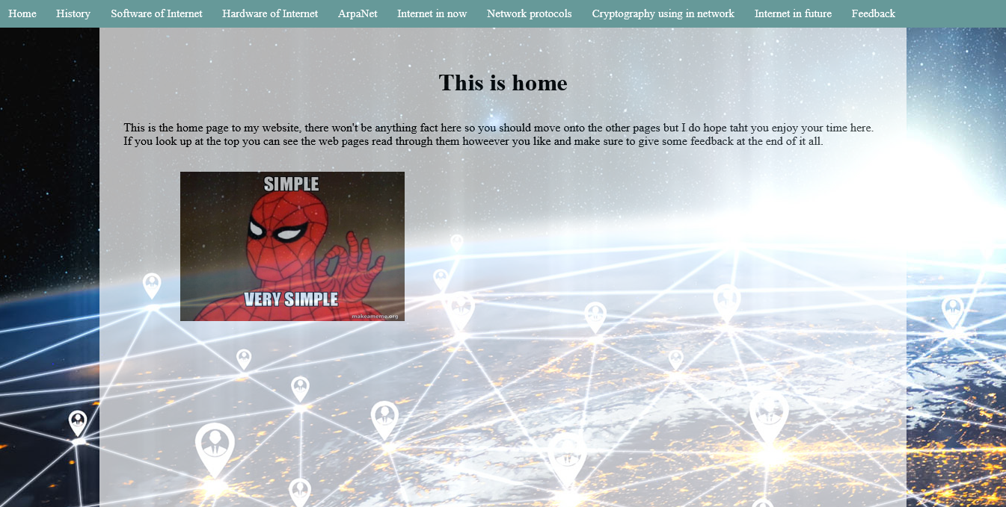

History

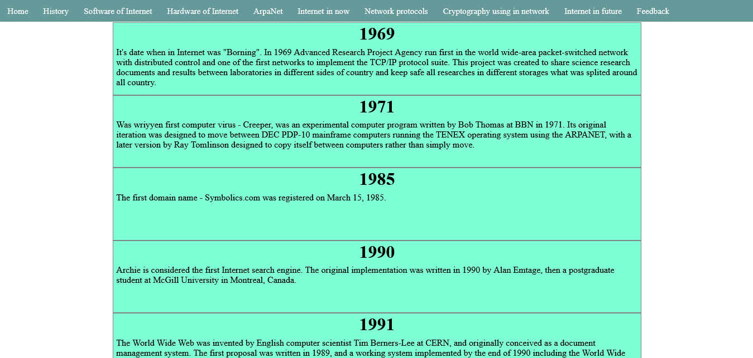

Software of Internet

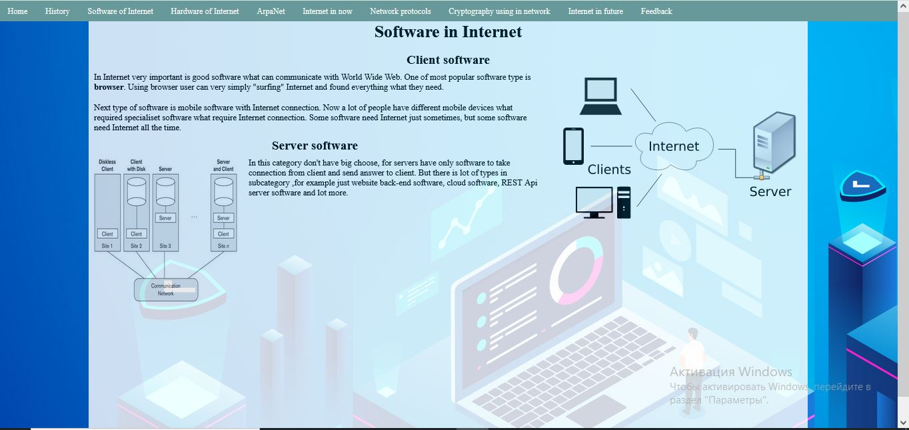

Hardware of Internet

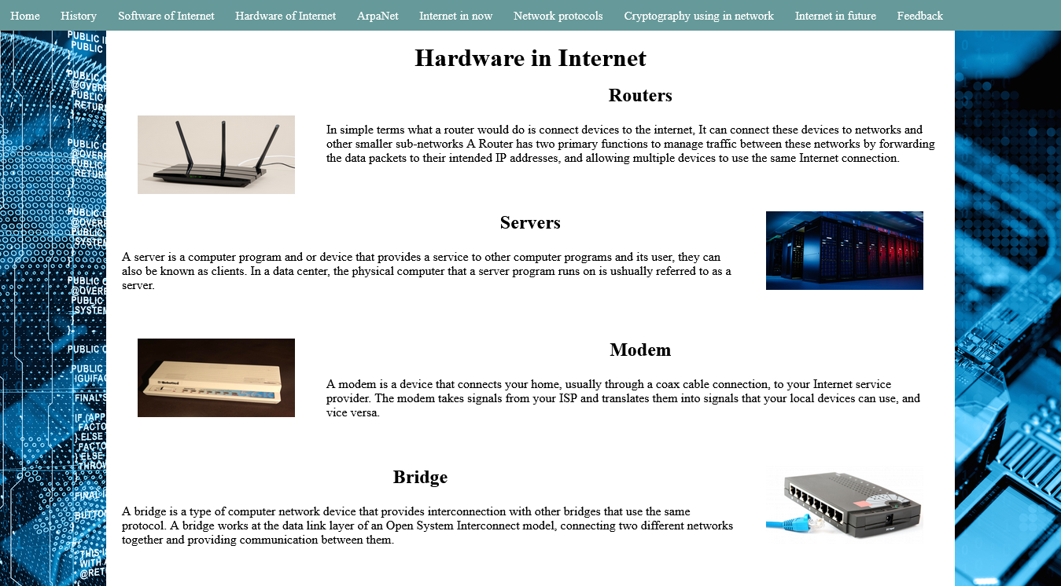

ArpaNet

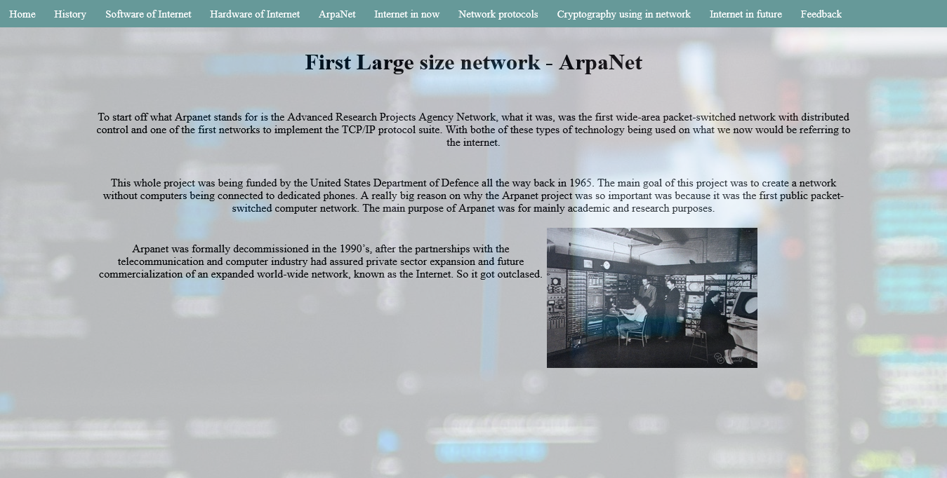

Internet in Now

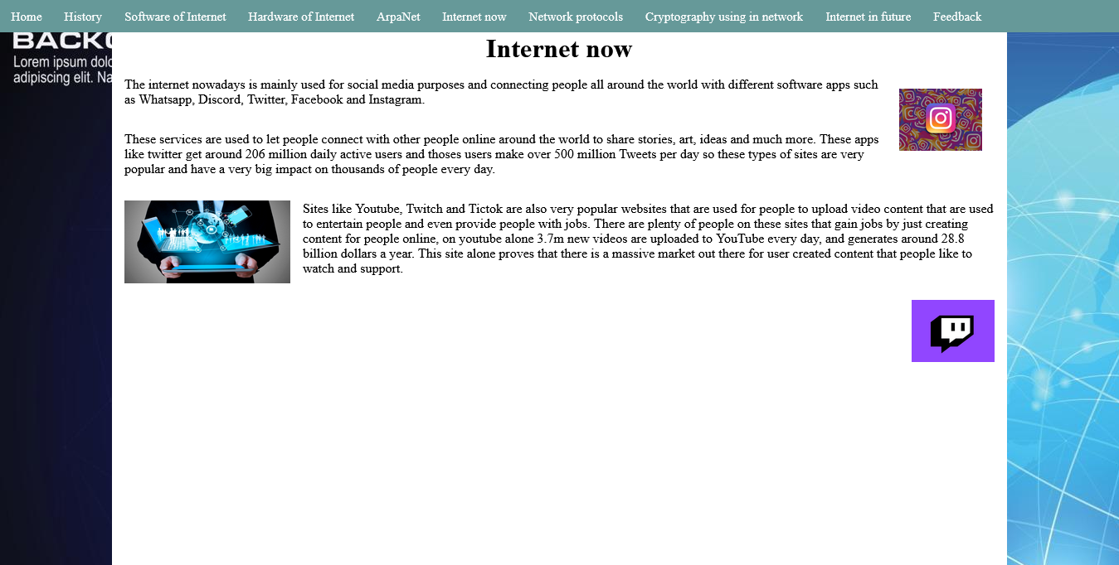

Network protocols

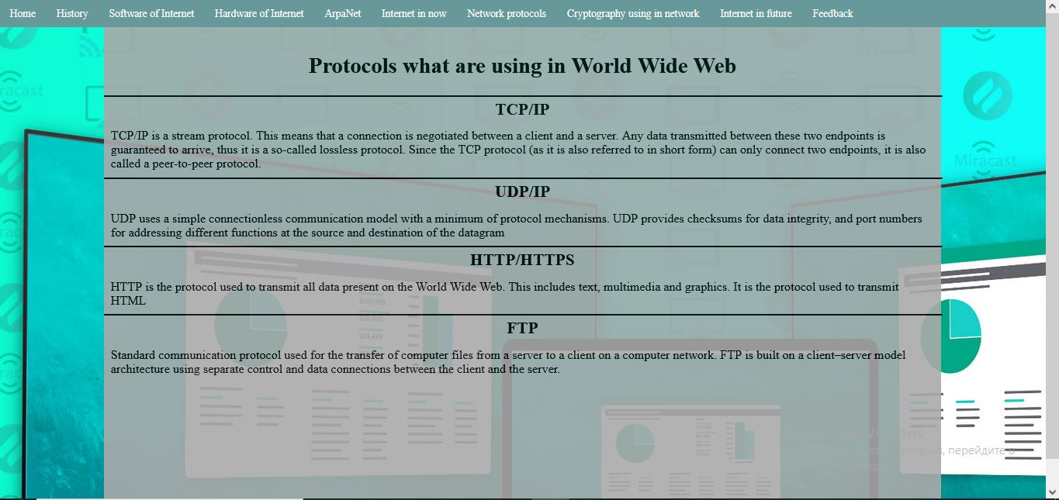

Cryptography using in network

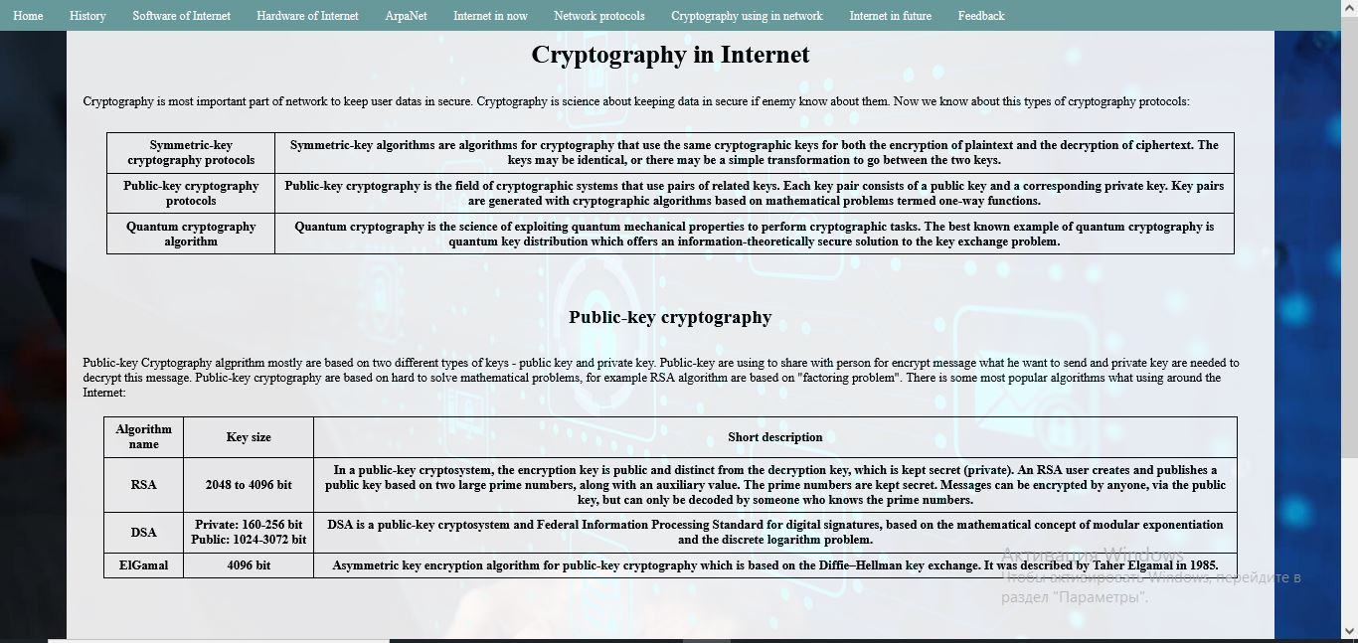

Internet in future

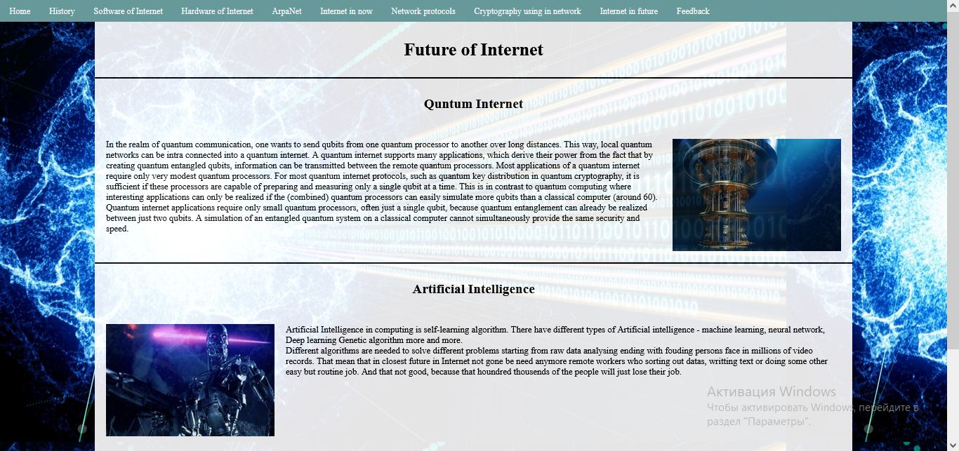

Feedback

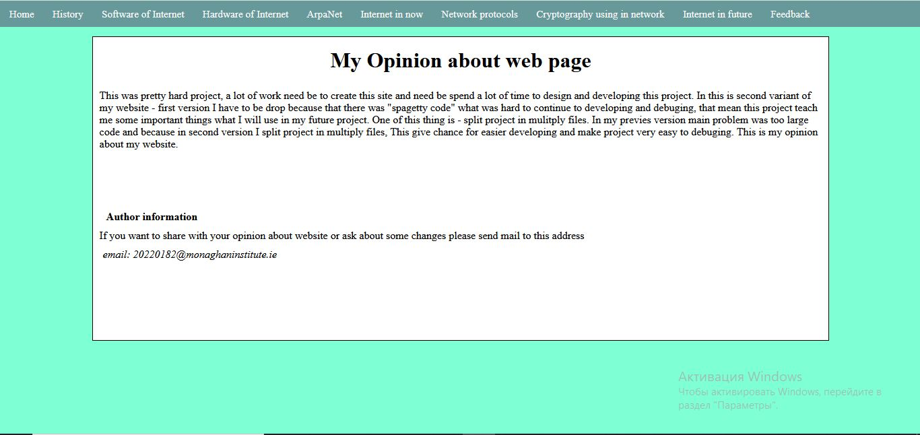

**Web Site HTML Codes**

There is link to github repository with website files :

[website source code](https://github.com/Ackit10/Website_web-authoring)